Testimony of Professor Lenni B. Benson
  - Professor of Law, New York Law School and
  - Executive Director, Safe Passage Project

Presented to the Immigration Committee

of the

New York City Council

June 27, 2016
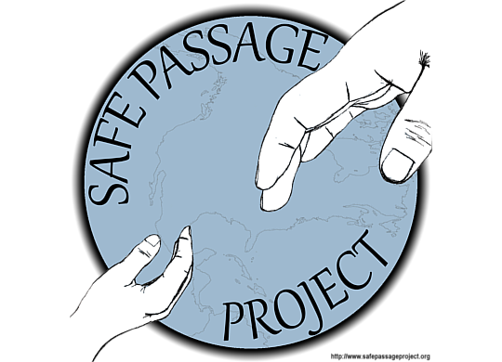

Dear Councilmember Carlos Menchaca and Members of the Immigration Committee:
I thank you for this opportunity to testify in support of the two resolutions pending before the committee this day: Resolution 1105 (seeking to expand support for the admission of Syrian Refugees) and Resolution 1097 (seeking Congressional improvements to the “U Visa Status”). I offer these remarks based on my over thirty years of experience in the field of U.S. immigration and nationality law and in my capacity as the Executive Director of the Safe Passage Project, a nonprofit that is serving immigrant youth in New York State.

Resolution 1105—Admission of Syrian Refugees

The United States is a generous country in granting refugee status to thousands of people each year and aiding in their resettlement to the United States. Yet while, our President has designated that the United States would accept an estimated 12,000 Syrian refugees this fiscal year (ending September 30, 2016), the government has not been able to complete the processing and admission of that number of refugees from the region. The City Council is a welcome leader, representing one of the most diverse cities in the world and leaders of a city where immigrant integration is a central commitment of our government and our communities. We can do better and we can do more.
Unlike the chorus of fearful, ill-informed politicians in some states who are frightened of refugees this resolution today sends a positive message of welcome. It is wrong to politicize the admission of refugees and to generate fear amongst the U.S. population. All refugees go through a lengthy and rigorous assessment of their claims for protection and our government investigates their backgrounds and all available evidence of their character. The significant delays in admitting refugees are largely due to these security measures.
Furthermore, this resolution is important because our state and local communities are able to offer coordinated support and services when people are admitted through the formal refugee process. Unlike other immigrants or those who seek asylum, when Refugees are admitted, the Refugee Resettlement Agencies are able to plan for their arrival, welcome them with plans for temporary housing and aid in securing education or employment opportunities. Many communities throughout our state have been enriched by the arrival of refugee communities both economically and culturally. In 2015, New York State accepted 4,502 of the 69,933 total refugees resettled in the United States. The Migration Policy Institute has calculated that New York State received 6% of the total 2015 refugee population.
Here is a graph showing the top receiving states from the MPI website:
FY 2015 total of nearly 70,000 refugee admissions:
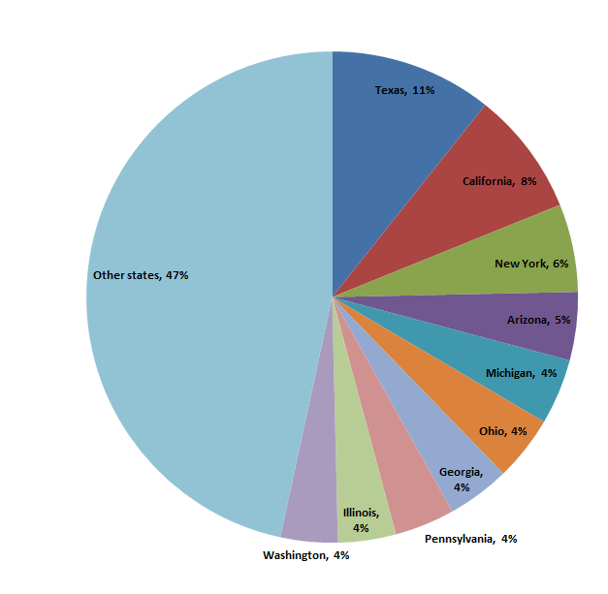
Source: http://www.migrationpolicy.org/article/refugees-and-asylees-united-states#Refugee Admission Ceiling

Undoubtedly many of the council members can point to local community organizations, successful entrepreneurs, and diverse educational institutions strengthened by past refugee admissions. The City’s own Department of City Planning has gathered data about our immigrant population and using federal data shares that nearly 13% of our all immigrants settling in our city are people who were admitted as refugees or later granted asylum.

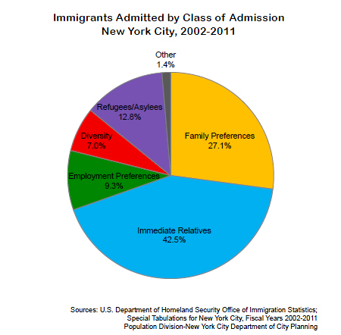

Under the Immigration and Nationality Act (INA), the President and Congress consult and the President selects a target admissions number for refugees. For many years the target has been approximately 70,000 but actual admissions have varied based on processing delays and security clearances. This allocation is further subdivided by regions. For fiscal year 2016 the President announced an increase in refugee admissions to help address the refugee crisis in Syria. President Obama stated that he would increase the annual limit to 85,000 and seek admission of at least 10,000 Syrians. While this is a positive step, it is insufficient to meet the resettlement needs generated by this and other crisis. The U.S. has done more during other periods of crisis. For example in the early 1990’s the United States raised the refugee admissions to a record high of 142,000. The vast majority of people resettled in 1993 were fleeing the crisis in the Balkans. Below is a chart of actual total refugee admissions.
Table 13. REFUGEE ARRIVALS: FISCAL YEARS 1980 TO 2013
Year Number Year Number Year Number
1980 207,116 1992 115,548 2004 52,840
1981 159,252 1993 114,181 2005 53,738
1982 98,096 1994 111,680 2006 41,094
1983 61,218 1995 98,973 2007 48,218
1984 70,393 1996 75,421 2008 60,107
1985 67,704 1997 69,653 2009 74,602
1986 62,146 1998 76,712 2010 73,293
1987 64,528 1999 85,285 2011 56,384
1988 76,483 2000 72,143 2012 58,179
1989 107,070 2001 68,925 2013 69,909
1990 122,066 2002 26,788 2014 69,975*
1991 113,389 2003 28,286
Note: Data series began following the Refugee Act of 1980. Excludes Amerasian immigrants except in Fiscal Years 1989 to 1991. Source: U.S. Department of State, Bureau of Population, Refugees, and Migration (PRM), Worldwide Refugee Admissions Processing System (WRAPS), Fiscal Years 1980 to 2013. *updated from 2014 USCIS data.
https://www.dhs.gov/sites/default/files/publications/ois_yb_2013_0.pdf
The Resolution before you is an appropriate and thoughtful response to the current demands of a world with a growing population of displaced people and refugees. The UNHCR announced that over 50% of this population is women and children and that the world has nearly 60 million people who are not able to remain safely at home.

Other Refugee Needs

Officially, the legal definition of a refugee is a person seeking help outside their country of origin and who is facing a well-founded fear of persecution on account of a protected ground. As the City Council is well aware, the INA also allows people to seek protection inside the United States by applying for asylum. The council and city government have been leaders in funding the work of nonprofits, including funding for the Safe Passage Project to aid unaccompanied minors seeking protection. We very much appreciate this needed support. On this occasion of the resolution supporting Syrian admissions, we note a third population that is betwixt and between the support found here in New York and the overseas refugee resettlement program. Listed in the top five most dangerous countries in the world are: El Salvador, Guatemala and Honduras and each of these nations has thousands of people fleeing each month seeking protection from endemic violence and a lack of governmental protection or failed government due to corruption and control by criminal syndicates.
In October of 2014 the federal government announced the creation of the overseas Central American Minors Program that authorizes the grant of refugee status inside Guatemala, Honduras, or El Salvador for children who have a parent residing with a form of legal status within the United States. This program authorized the adjudication of refugee claims within the country of residence, a very rare exception to the normal requirement that people must seek protection from outside their country of origin. The main rationale of this program was to deter children from fleeing the violence in the region to secure reunification with a parent or parents in the United States. The program was also necessary for a significant number of Central Americans who reside lawfully in the United States in Temporary Protected Status (TPS) or another category such as deferred action but are unable to sponsor their children to join them. The federal government asked the Refugee Resettlement Agencies to process the preliminary applications of the parents for the children. To my knowledge these agencies were not given any additional funding to handle the processing of the documents which must both establish the genetic parentage of the child and prove the lawful status of the parent before the child can be interviewed in Central America. While the program’s objective is empathetic, the overall operation of the program has been troublingly slow and cumbersome.
In a soon to be released report the USCIS Ombudsman will report that despite thousands of applications by parents, only a small number of children have been admitted.
As of March 28, 2016, only 144 individual beneficiaries—46 refugees and 98 parolees—had arrived in the United States through the CAM program. Of those, 93 arrived from El Salvador, 46 from Honduras and 5 from Guatemala.
The Customs and Border Protection website reports more optimistic data, but approvals are not admissions to the United States:
To date, the Central American Minors Program has received applications for 8,948 individuals, and we have approved more than 1,448 individuals for refugee status or parole in El Salvador, Honduras, and Guatemala. Source: https://www.cbp.gov/newsroom/stats/southwest-border-unaccompanied-children/fy-2016
It is sad to say, but children facing immediate danger and families worried for their safety apparently have continued to have to face the great dangers of the journey to the United States because the processing of claims is so slow.
Just as children and families are suffering in fleeing the violence in Syria, I urge the City Council to amend its current resolution or to consider adopting an additional resolution calling for robust funding of the Central American refugee processing and to dramatically increase the admission of refugees from the region. These admissions through the refugee system will allow our state and local government to better prepare for the resettlement of the populations and to receive small amounts of federal assistance to help face potential special funding demands on schools or communities of resettlement.

Quota Delays for Central American Special Immigrant Juveniles

Soon the Immigrant Children’s Advocates Relief Effort, a coalition of several nonprofit immigrant services providers will update this committee on the ongoing needs of serving city immigrant children who are seeking protection from the Central American region. The federal government continues to apprehend children at record rates. In May, the most recent month of data available, the Border and Customs Protection reported that another 5,669 children had been apprehended and an additional 6,788 number of young women and small children. This rate of apprehension is higher than all but one prior year. The United States could easily see over 60,000 youth in fiscal year 2016 alone. We hope that the City Council will continue to support our efforts to assist these children by helping to fund legal services and by coordinating other city agencies to provide integration support. All of these factors, of increasing violence in the region, the quota delays, and the government lack of action on pending cases will conflate to place enormous demands on those trying to protect immigrant youth in our city.

A Call for Temporary Protected Status

Finally, I note that Congress has given the President authority to certify Temporary Protected Status for people inside the United States who cannot return safely to their country of origin due to unrest or natural disaster. The President made such a designation for Syrians in 2014. There have been continuing designations for some people from El Salvador and Honduras for many years due to natural disasters that occurred in many years ago. Today there is a national effort to have the President once again designate TPS and to expand it to include Guatemala. There are many good reasons to support this temporary protected status and to allow for family reunification. Especially in times of great turmoil and government instability, this solution may be both legal necessary and essential to humanitarian protection.
The hearings today on similar resolutions calling for federal government action, set a good example and I urge this committee and the entire City Council to consider similar resolutions in support of Temporary Protection Status for the Northern Triangle of Central America. I have signed such a request with a group of immigration law professors and the full petition can be found here: http://immigrantjustice.org/sites/immigrantjustice.org/files/2016_02_26_ProfessorTPSLetter.PDF

Conclusion

In conclusion, I write to support the City Council’s support for expanding protections for Syrian refugees and for improving the adjudication and protection of victims of crimes under the “U” visa status. I also urge the Council to go further to call for expanded support for the processing of refugee protection in the region for Central American Minors, to call upon the federal government to protect children who have special immigrant juvenile findings and are stuck in quota delays, and to join me in calling for Temporary Protected Status for people in the United States who are from El Salvador, Guatemala, or Honduras.

Thank you for the opportunity to address the counsel.

Respectfully submitted,

Lenni B. Benson

Unaccompanied Children Apprehended at the Southern Border by Fiscal Year through May 31, 2016.
Country | FY 2009 | FY 2010 | FY 2011 | FY 2012 | FY 2013 | FY 2014 | FY 2015 | FY 2016
El Salvador | 1,221 | 1,910 | 1,394 | 3,314 | 5,990 | 16,404 | 9,389 | 11,404
Guatemala | 1,115 | 1,517 | 1,565 | 3,835 | 8,068 | 17,057 | 13,589 | 12,337
Honduras | 968 | 1,017 | 974 | 2,997 | 6,747 | 18,244 | 5,409 | 6.152
Mexico | 16,114 | 13,724 | 11,768 | 13,974 | 17,240 | 15,634 | 11,012 | 8,052

One of the important changes to note in the representation of these youth is that the country cap quota has been reached for the yearly allocation of special immigrant juvenile status visas (SIJS). SIJS is a status for children who have been abused, neglected, or abandoned by one or both parents and who cannot return to their country of origin. While it is a form of protection similar to refugee status, it is a category that Congress limits by an annual quota (very much like the U visa quota discussed in Resolution 1097). The annual visa allocation is charged to the Employment Based 4th Preference for Special Immigrants. That is a total allocation of approximately 9,600 or 7.1% of the employment based visas. This number is further restricted by country caps where no nation can receive more than 7% of the total visas or approximately 695 children per county. In May the quota was reached for nationals from El Salvador, Guatemala, or Honduras. In July, the quota will be reached for children from Mexico and in August it is likely to be reached for children from India. Only Congress can raise these allocations, there is no discretionary pool of visas for the administration to distribute.
Given these restrictions, many more children are now likely to need assistance to also seek protection under the refugee convention by filing for asylum. In FY 2014, 14,000 children filed for asylum protection and the DHS reported they expected a similar number of applications this fiscal year. However, advocates have advised the agencies to expect more asylum applications for children fleeing Central American due to the queues and delays that will be expected in the SIJS categories.
The City Council might consider future resolutions calling for greater protections for these immigrant youth. For all SIJS cases, a New York state family court has already made a finding that the care of custody of the child is to be found in New York and that it is not in the best interests of the child to be returned to his or country of origin. While quota delays may mean long waits, the DHS should stop the deportation of these children and recognize and respect the sovereign findings of the state courts of New York. We have asked the DHS to consider various interim forms of relief for these youth such as deferred action or a form of “parole” to protect the children from removal and to allow them to seek federally issued employment authorization documents. To date the DHS has not yet developed a formal policy and it may be that like the U status applicants discussed in Resolution 1097, these youth will continue to be stressed and vulnerable to exploitation and removal due to the unfortunate complexities of the immigration system.
When our state courts have ruled that a child’s best interests are found here in New York, that determination should be respected by the federal authorities and an efficient, low cost, path to stability and inclusion must be found.

