Advisory Memorandum #2

To: Family Court Judges, Chief Clerks and Non-judicial Staff

From: Advisory Council on Immigration Issues in Family Court

Re: Guidance on Family Court Role in U Nonimmigrant Status Certification

Date: February 14, 2017

The Advisory Council on Immigration Issues in Family Court, co-chaired by Hon. Ruben Martino, Supervising Judge, Family Court, Bronx County, and Theo S. Liebmann, Clinical Professor and Director of Clinical Programs, Hofstra Law School, was appointed by Chief Administrative Judge Lawrence Marks in 2015. The Council has prepared this memorandum as the second in a series of memoranda, bench aids and other documents to address the variety of immigration issues arising in and as a result of Family Court proceedings. It was prepared primarily by the Council’s Subcommittee on U Nonimmigrant Status and is intended to assist Family Court jurists and non-judicial staff regarding the role of family court judges, referees, and magistrates in the U Nonimmigrant Status certification process. [A list of the Council’s members, including the Subcommittee, is attached as Appendix A to this
memorandum].

Background

In 2000, Congress created U Nonimmigrant Status to grant immigration status to victims of certain specified crimes, including domestic violence. Adults and children with U Nonimmigrant Status receive, among other benefits, temporary permission to stay in the U.S. for four years, employment authorization to work legally in the U.S., and the ability to apply for lawful permanent residence. The statutory requirements for U Nonimmigrant Status are outlined in 8 U.S.C. § 1184(a)(15)(U), which provides that applicants must submit “a certification from a Federal, State, or local law enforcement official, prosecutor, judge, or other Federal, State, or local authority” that the applicant ‘has been helpful, is being helpful, or is likely to be helpful’ in the investigation or prosecution of criminal activity.” This certification takes the form of Form I-918 Supplement B, U Nonimmigrant Status Certification (“I-918 Supp B”). Following submission of the I-918 Supp B and several other documents demonstrating an applicant’s eligibility for the relief, the Department of Homeland Security (“DHS”) makes the final decision on whether to grant U Nonimmigrant Status.
New York has prioritized the processing of the I-918 Supp B form by certifying agencies, both at the state and city levels. Fair administration of the process depends upon the consistent participation of family court judges, referees, and magistrates, who are important certifiers in New York. Part 1 of this document reviews the trajectory of the I-918 Supp B and the common ways they come to family court jurists. It clarifies that I-918 Supp B may be certified at various stages of a case, pursuant to federal law. Part 2 provides answers to some frequently asked questions by family court jurists encountering the certification process. Finally, Part 3 offers guidance on how to complete the I-918 Supp B, setting forth detailed descriptions of each section and specific instructions on how to fill them out.
Part 1: Certification Requests Presented to Family Court Judges, Magistrates and Referees

Under the DHS guidelines, family court judges, referees, and magistrates are certifying authorities for U Nonimmigrant Status purposes. They have the authority to certify that an applicant “was helpful, is being helpful, or is likely to be helpful in the detection, investigation or prosecution of [qualifying] criminal activity.”

Family court jurists are often in the position of “detecting” criminal activity, consistent with the meaning of criminal activity under the U Nonimmigrant Status statute. Under the statute, domestic violence, abusive sexual contact, felonious assault, blackmail, extortion, and sexual assault are all qualifying criminal activities. Proceedings in which family courts might encounter qualifying criminal activity include:

- Family Offense Cases, including Temporary Orders of Protection granted ex parte;
- Custody, Visitation, and Guardianship Cases, in which domestic violence is alleged or a child has been kidnapped;
- Abuse and neglect proceedings;
- Juvenile Delinquency proceedings;
- Child and Spousal Support proceedings, in which there are allegations of blackmail or extortion;
- Violation Petitions; and
- Other cases where appropriate.

Under DHS Guidelines, certification requests may be made at any point in a proceeding and helpfulness means that the person seeking the certification has not “unreasonably refused to cooperate” or “failed to provide information or assistance reasonably requested.”

Part 2: Frequently Asked Questions

1. Does the signing of a certification form by a family court jurist grant the applicant U Nonimmigrant Status?
No. United States Citizenship and Immigration Services (“USCIS”) makes the determination whether to grant U Nonimmigrant Status after a full application review. Certifications are just one required submission in the complete application for U Nonimmigrant Status. There are several other eligibility requirements.

2. Who initiates the U Nonimmigrant Status certification process?
The process for signing the U Nonimmigrant Status certification may be initiated by the certifying authority (e.g. state court) or by an individual seeking the certification. The applicant may be assisted by an advocate or an attorney.

3. At what stage of a case can a family court jurist sign a certification?
A family court jurist may sign the I-918 Supp B as soon as the jurist is able to assess a person’s helpfulness or willingness to be helpful in the detection, investigation, or prosecution of criminal activity. There is no requirement that a jurist make factual findings prior to signing a certification. Certifications may be signed after the filing of a petition. They may also be signed after a temporary order of protection is granted ex parte, but before the order of protection is final. There is no statute of limitations on signing certifications after a case has been closed.

4. Must there be criminal charges in order for a family court jurist to sign a certification?
No. There is no statutory or regulatory requirement that an arrest, prosecution, or conviction occur for someone to be eligible to apply for U Nonimmigrant Status. A family court jurist can certify if proceedings are only in family court.

5. Must the signing family court jurist have been the jurist on the underlying matter to sign a certification?
No. Under the regulations and guidelines, any designated certifying agent or any federal, state, or local judge, magistrate, or referee may sign a certification. There is no requirement that the signing jurist or agent have dealt with the underlying case. A family court jurist may therefore sign a certification in connection with a matter presided over by someone else upon familiarizing themselves with the underlying record and finding sufficient evidence of “helpfulness.” This can happen when someone becomes unavailable due to retirement, relocation, or leaving the bench for other reasons.

6. What constitutes “helpfulness” under the U Nonimmigrant Status statute?
The governing statute, 8 U.S.C. § 1101(a)(15)(U), requires certification that an applicant “has been helpful, is being helpful, or is likely to be helpful” in the investigation or prosecution of criminal activity. Thus, helpfulness may consist of the applicant’s past, current, or future conduct relating to the underlying activity. USCIS regulations require only that “since the initiation of cooperation, the victim has not unreasonably refused to cooperate or failed to provide information and assistance reasonably requested by law enforcement.” Several examples of “helpful” behavior in family law cases have been identified:

- seeking an order of protection;
- receiving an ex parte order of protection;
- receiving an order of protection on consent of all parties;
- reporting violations of an order of protection;
- reporting child abuse or neglect;
- reporting elder abuse;
- attempting to report violations of an order of protection unsuccessfully due to a failure to provide an interpreter;
- providing evidence of domestic violence or child abuse or neglect;
- providing information regarding child / elder abuse to protective services / investigators;
- reporting violations of family court custody and visitation orders that involve criminal activity, such as domestic violence;
- providing evidence or testifying in a child or elder abuse or neglect case; or
- providing a history of violence in court papers.

Conclusion

Following a list of Advisory Council members (Appendix A), this memorandum contains a step-by-step guide for jurists in filling out U Nonimmigrant Status certifications (Appendix B).

We hope that the guidance provided in this memorandum will clarify some of the questions and concerns raised with Council members by the judiciary and by advocates regarding requests for judicial certifications to be submitted to Federal immigration authorities by litigants in conjunction with their applications for U Nonimmigrant Status.

cc.: Hon. Michael Coccoma
Hon. Fern Fisher
Administrative Judges
John W. McConnell
Ron Younkins
Hon. Ruben Martino
Theo S. Liebmann
Janet Fink

APPENDIX A
Advisory Council on Immigration Issues in Family Court (Feb., 2017)¹

Co-Chair: Professor Theo Liebmann, Clinical Professor of Law and Director of Clinical Programs, Hofstra Univ. School of Law
Co-Chair: Hon. Ruben Martino, Supervising Judge, Family Court, Bronx County
Counsel to the Advisory Council: Janet Fink, Esq., Deputy Counsel, NYS Unified Court System

MEMBERS:

1. Bree Bernwanger, Esq., Feerick Center for Social Justice, Fordham University School of Law
2. Hon. Lisa Bloch-Rodwin, Judge of the Family Court, Erie County
3. Margaret Burt, Esq., Attorney, Pittsford, NY
4. Myra Elgabry, Esq., Director, Immigrant Rights Project, Lawyers for Children, New York, NY
5. Anne Erickson, Esq., President and CEO, Empire Justice Center, Albany, NY
6. Hon. Alison Hamanjian, Judge of the Family Court, Richmond County
7. Terry Lawson, Esq.,* Director, Family and Immigration Unit, Legal Services of
New York - Bronx County
8. Joanne Macri, Esq., Director of Regional Initiatives, NYS Office of Indigent Legal Services
9. Kathleen Maloney, Esq., Immigration Law Unit, Legal Aid Society, New York, NY
10. Hon. Edwina Mendelson, Acting Supreme Court Justice, New York, NY
11. Andrea Panjwani, Esq., Managing Attorney, My Sister’s Place, White Plains, NY
12. Carmen Rey, Esq., Deputy Director, Immigration Intervention Project, Sanctuary for Families,
New York, NY
13. Professor Sara Rogerson, Esq., Director, Immigration law Clinic and Law Clinic and Justice Center, Albany Law School
14. Wedade Abdallah, Esq., Assistant Public Defender, Legal Aid Society of Rochester
15. Maureen Schad, Esq., Pro Bono Counsel, Chadbourne and Park, L.L.P.
16. Amelia T. R. Starr, Esq.,* Parner, Davis Polk and Wardwell, L.L.P.
17. Eve Stotland, Esq., Director, Legal Services Center, The Door, New York, NY
18. Trinh Tran, Esq.,* Staff Attorney, Sauti Yetu Center for African Women and Families, Bronx, NY
19. Lee Wang, Esq., Skadden Fellow, Immigrant Defense Project, New York, NY

APPENDIX B
Filling Out the Form I-918 Supplement B, U Nonimmigrant Status Certification

Below is a captioned guide to completing the Form I-918 Supp B. Further resources for completing the U Nonimmigrant Status certification are USCIS website at https://www.uscis.gov/i-918, DHS Certification Resource Guide and NIWAP’s U Visa: “Helpfulness.”

- Print legibly in black ink or type.
- If extra space is needed to complete any item, attach a continuation sheet, indicate the item number, and date and sign each sheet.
- The certifying official makes the initial determination as to the helpfulness of the petitioner. USCIS will give a certification significant weight but it will not be considered conclusory evidence that the victim has met eligibility requirements.

Leave this column blank.

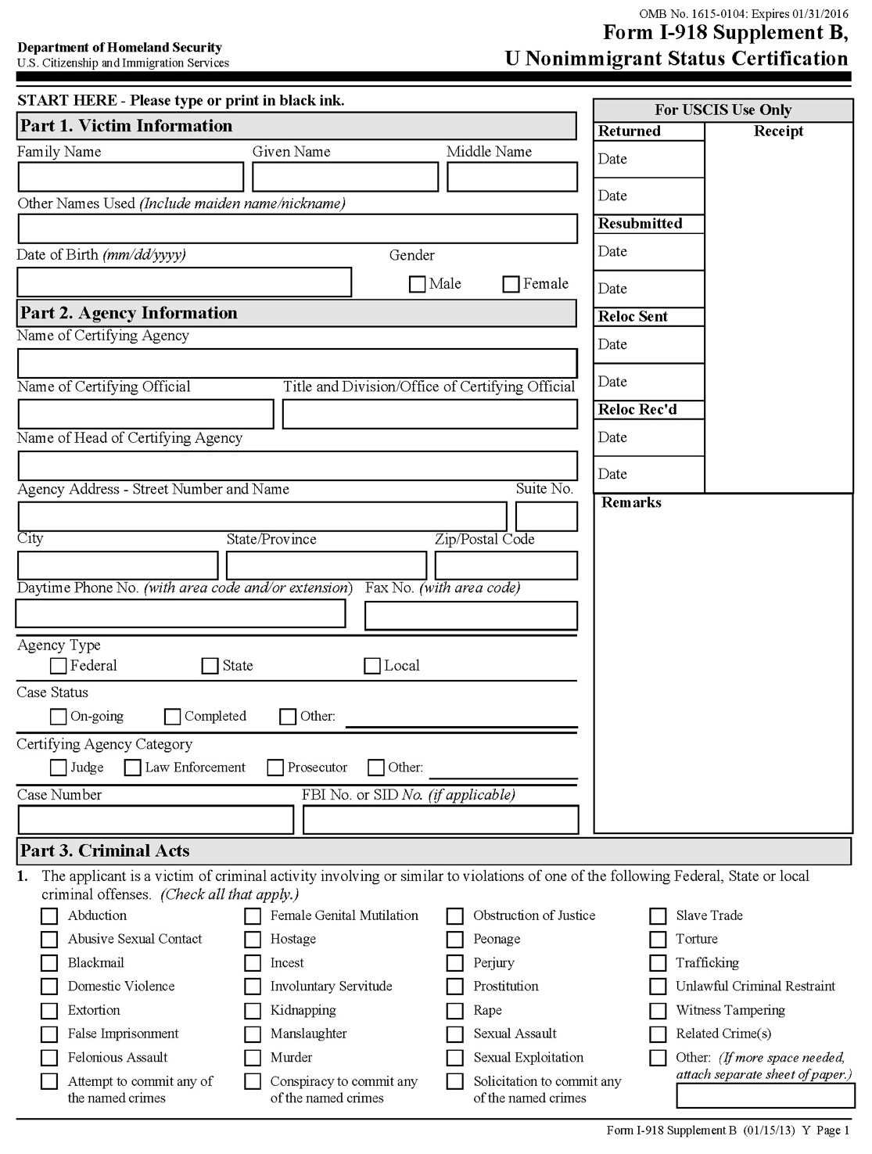
A family court judge, magistrate, or referee, is both a “certifying agency” and a “certifying official.”
Check all of the acts in which the petitioner is a victim. Acts include conduct that triggers jurisdiction under the Family Court Act, e.g. domestic violence.
Provide the court’s mailing address.
Part 1 is usually filled out by the applicant or applicant’s counsel.

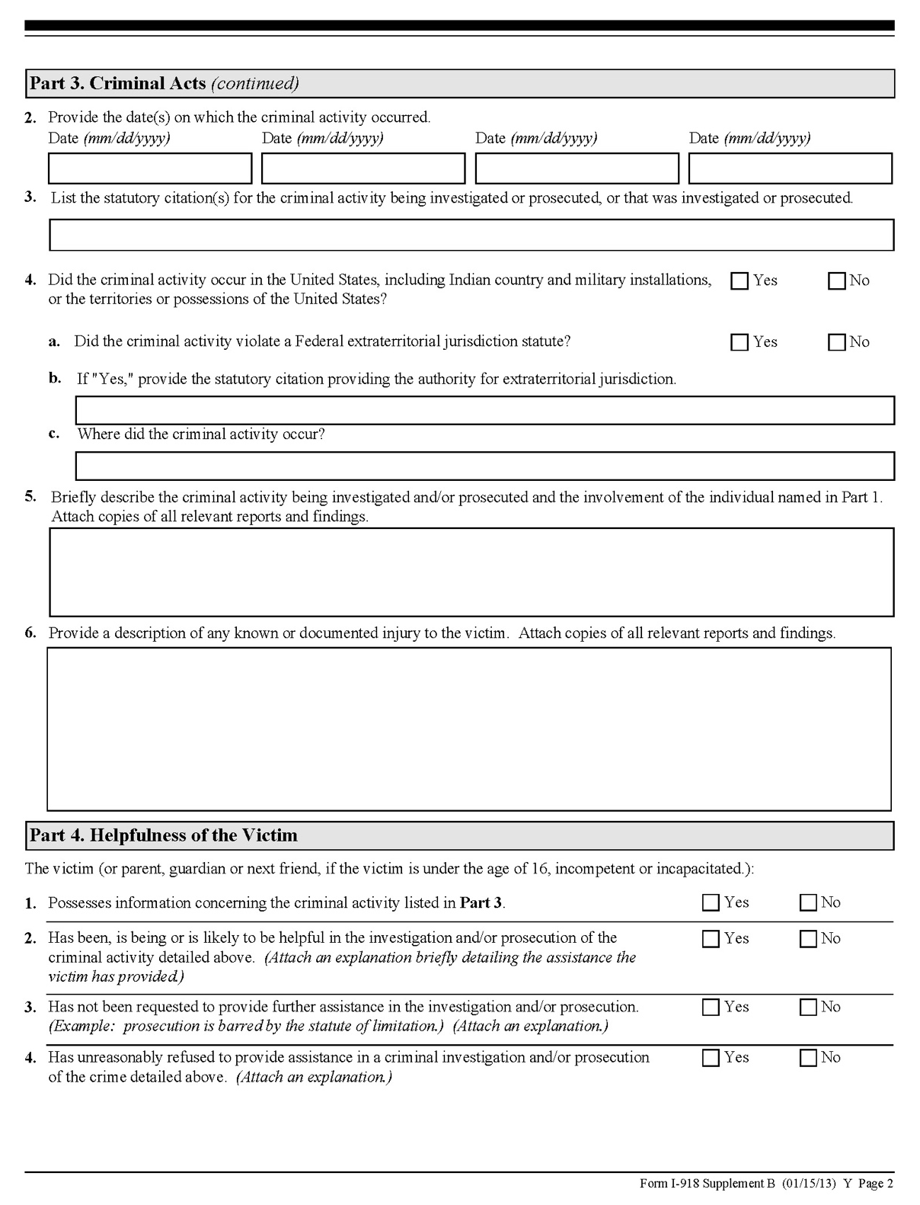
A petitioner is considered to possess information concerning the criminal activity of which he or she is a victim if he or she has knowledge of details concerning the criminal activity.
The standard of cooperation sufficient to constitute helpfulness is low. USCIS regulations require only that the applicant has not refused or failed to provide information and assistance reasonably requested.

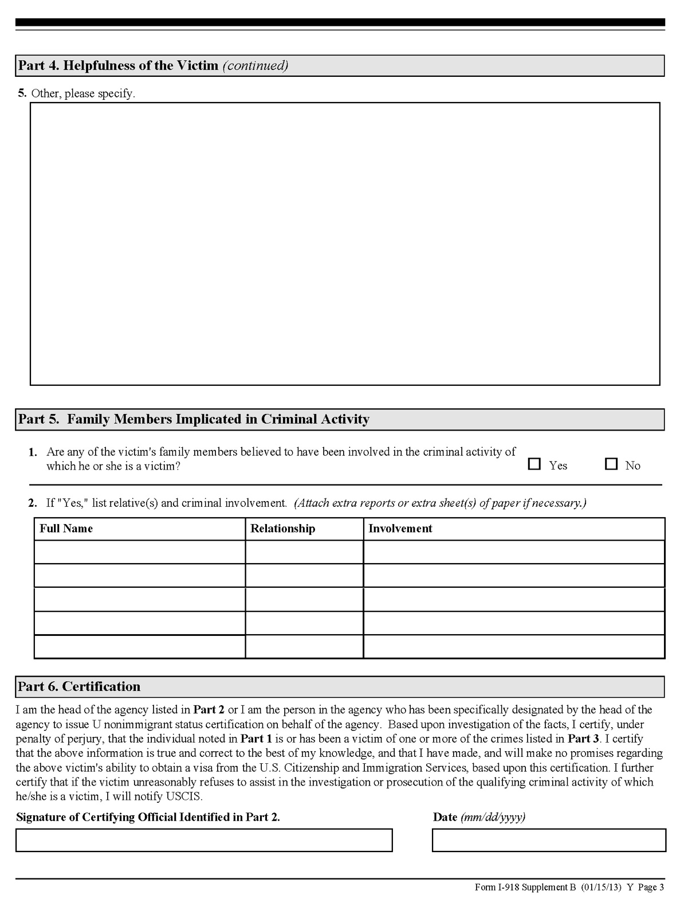
Include information about any family members culpable in the criminal activity.
Provide an explanation of the applicant’s helpfulness to the investigation or prosecution of the criminal activity. Helpfulness can take a broad array of forms (see FAQ 6 for a non-exclusive list of helpful activities).
Sign and date the certification.

See U.S.C. § 1101 et. seq.
See INA §§214(p)(6); 214(p)(3)B); 245(m).
8 U.S.C. § 1184(p)(1).
The information contained in the required certification is important, but not dispositive as to whether DHS will issue a certification. See New Classification for Victims of Criminal Activity; Eligibility for “U” Nonimmigrant Status, 72 Fed. Reg. 53,014, 53,019-24 (Sept. 17, 2007) (codified at 8 C.F.R. pts. 102, 212, 214, 218, 274a, 299).
Governor Cuomo, for example, included establishing official certification protocols for law enforcement agencies in his 2016 State of the State address. See N.Y. St., 2016 State of the State, available at https://www.governor.ny.gov/sites/governor.ny.gov/files/atoms/files/2016_State_of_the_State_Book.pdf. Moreover, the New York City Commission on Human Rights announced that it is accepting requests for U Nonimmigrant Status certifications. See Press Release, Office of the Mayor, Mayor de Blasio Announces NYC Commission on Human Rights First Such Agency in Major U.S. City to Issue U and T Visa Certifications (Feb. 9, 2016) (on file with author).
See N.Y. State Judicial Comm. on Women in the Courts, Immigration and Domestic Violence: A Short Guide for New York State Judges 3 (Apr. 2009), available at https://www.nycourts.gov/ip/womeninthecourts/pdfs/ImmigrationandDomesticViolence.pdf#page=5&zoom=auto,-157,148.
See 8 C.F.R. § 214.14(a)(2); 72 Fed. Reg. 53,014, 53,023-53,024 (Sept. 17, 2007).
Dep’t of Homeland Sec., U and T Visa Law Enforcement Resource Guide (last updated Jan. 8, 2016), available at https://www.dhs.gov/xlibrary/assets/dhs_u_visa_certification_guide.pdf (hereinafter DHS, Certification Resource Guide). For a list of qualifying criminal activity, see 8 U.S.C. §1101(a)(15)(U)(iii). This list, however, is non-exclusive.
See 8 U.S.C. § 1101(a)(15)(U)(iii).
Id. at 4; see also N.Y. State Judicial Comm. on Women in the Courts, Immigration and Domestic Violence: A Short Guide for New York State Judges (Apr. 2009) at 3, available at https://www.nycourts.gov/ip/womeninthecourts/pdfs/ImmigrationandDomesticViolence.pdf#page=5&zoom=auto,-157,148.
DHS Certification Resource Guide, at 18-19.
Id. § 1101(a)(15)(U)(i). See also DHS, Certification Resource Guide at 4.
See 8 U.S.C. § 1184(p) (2014) (setting forth application requirements).
DHS, Certification Resource Guide at 8.
Id at 5.
See N.Y. State Judicial Comm. on Women in the Courts, Immigration and Domestic Violence: A Short Guide for New York State Judges at 3. See also 72 Fed. Reg. 53,014, 53,019 (“USCIS believes that Congress intended for individuals to be eligible for U nonimmigrant status at the very early stages of an investigation.”).
Id.
DHS, Certification Resource Guide at 10, 18-19.
Id at 11.
Id. at 9.
8 C.F.R. § 214.14(a)(3)(ii).
Id.
The family court jurist need only verify the victim’s “helpfulness.” See DHS, Certification Resource Guide at 4. In one of the few available New York Family Court opinions regarding a U Visa certification, the court issued the requested certification based on a transcript of previous proceedings where the presiding judge had retired. See In re Rosales, 40 Misc. 3d 1216(A) (N.Y. Fam. Ct. 2013) (unreported table disposition).
DHS, Certification Resource Guide at 18.
Benish Anver, et al., U-Visa: “Helpfulness”, NIWAP (Jul. 23, 2015), available at http://library.niwap.org/wp-content/uploads/2015/IMM-Checklist-UVisaHelpfulness-09.25.13.pdf (enumeration and punctuation added).
¹ Affiliations are listed for identification purposes only. Members, whose names are marked with an asterisk (*), participated in the U-non-immigrant Status Subcommittee, which was primarily responsible for the preparation of this guidance document.

